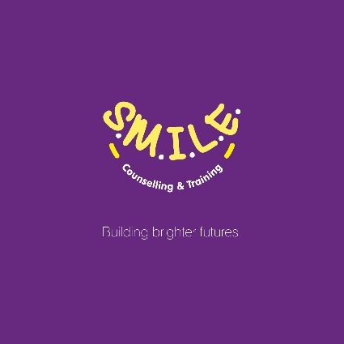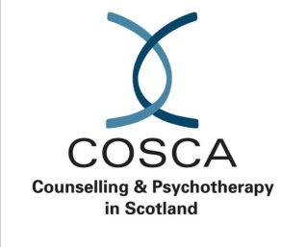
COSCA CERTIIFICATE IN COUNSELLING SKILLS.
COHORT 6

6TH September, 2022 to 26th September, 2023 inclusive
17.30 – 20.30, Tuesday evenings
ONLINE VIA TEAMS
Trainer: Martha Pollard
The course consists of four modules, each comprising 30 hours of formal instruction. Over the course duration, these are accumulated to gain the COSCA Certificate in Counselling Skills.
The four modules each contain elements of skills, knowledge, self-awareness and ethics, which includes an element of self-reflection within a confidential environment. There are four themes associated with the modules
- Module 1 - listening
- Module Two: responding
- Module Three: self-reflection
- Module Four: integration
This is an accredited counselling course which, on completion, can enhance employment opportunities and open possible further study options.
Participants will learn:
- About counselling skills and approaches
- How to apply these skills either within the workplace or for personal development
- About the difference between Counselling as a professional activity and Counselling Skills that could prove valuable for people in a wide variety of occupations.
The cost is £280 per Module (£1120 for the whole course including materials, handbooks and certificate).
You may pay by bank transfer or by card (credit or debit card). In either case, you will be invoiced one month in advance of each Module payment is due 2 weeks before each module starts.
The course will be delivered online via ZOOM
Timetable - Cohort 6
The proposed timetable is detailed below:
Units | Module 1 | Module 2 | Module 3 | Module 4
1 | 06 September 2022 | 13 December 2022 | 04 April 2023 | 11 July 2023
2 | 13 September 2022 | 20 December 2022 | 11 April 2023 | 18 July 2023
3 | 20 September 2022 | 10 January 2023 | 18 April 2023 | 25 July 2023
4 | 27 September 2022 | 17 January 2023 | 25 April 2023 | 01 August 2023
5 | 04 October 2022 | 24 January 2023 | 02 May 2023 | 08 August 2023
6 | 11 October 2022 | 31 January 2023 | 09 May 2023 | 15 August 2023
7 | 25 October 2022 | 07 February 2023 | 16 May 2023 | 22 August 2023
8 | 01 November 2022 | 14 February 2023 | 23 May 2023 | 29 August 2023
9 | 08 November 2022 | 21 February 2023 | 30 May 2023 | 05 September 2023
10 | 15 November 2022 | 28 February 2023 | 06 June 2023 | 12 September 2023
11 | 22 November 2022 | 07 March 2023 | 13 June 2023 | 19 September 2023
12 | 29 November 2022 | 14 March 2023 | 20 June 2023 | 26 September 2023

TO APPLY PLEASE CLICK THE LINK BELOW, COMPLETE THE FORM AND SUBMIT.
https://forms.office.com/r/8xdv6cauP8

